Code review form
(complete in no less than 1 hours, no more than 2 hours)

Code review report for code reviewer
Note that this report only gives marks for the reviewer, the reviewee does not get marks, neither positive for a good review, nor negative for a bad review. Reviewing leniently (all good, no remarks) for the reviewee's sake will not benefit them, but may harm your mark as reviewer. Such a review may lose marks due to 'lazy reviewing'. A subset of code reviews will be selected by the TA for a second opinion. Mark any issues that need fixing with a letter (A), (B), etc. Use these letter codes in your review comments at the end of this form.
Code reviewer details
Reviewer project | swapchain/viewscope
Reviewer  name & nr | Adam | Foflonker |  | FFLADA001
Review date | 10/10/2026
Details of team under review
Project | olbchi002/team-as-a-service (viewscope)
Student under review name & nr | Ibrahim | Sow |  | SWXIBR002
Backlog item | Backlog item 8: Camera Placement
item start + end date | 14 Aug 2026 |  | 30 Aug 2026
Link to gitlab repo | https://gitlab.cs.uct.ac.za/olbchi002/team-as-a-service
Commit history | See appendix C.
Acceptance criteria | Placement  - Picking a point/direction in the scene and entering a pose manually must produce equivalent cameras, sharing the same underlying state.  - A camera inside the collision-free flight volume is accepted.  - A camera outside the volume is clearly flagged as invalid, with a message explaining why.  Coverage  - Only visible targets are highlighted. Blocked targets are never highlighted, even if in the field of view.  - Moving a camera updates every affected view, not just the 3D scene including the heatmap, sector chart, and the target-detail panel if the selected target is affected.  Test Cases  - Place a camera via picking.  - Place a camera via pose entry.  - Place a camera on the edge of flight volume.  - Place a camera outside flight volume.  - Target hidden behind structure but facing camera.  - Move a camera.  - Remove a manually placed camera.
Start reviewing now
Start date & time of the review | 10/10/2026 @ 9:51 AM
DoD checklist
Compile compiles | Yes
Compiler warnings | Python interpreter warnings:  - QFont::setPointSize: Point size <= 0 (-1), must be greater than 0  - QWindowsWindow::setGeometry: Unable to set geometry 525x285+0+39 (frame: 525x285+0+39) on QWidgetWindow/"CameraPreviewWidgetClassWindow" on "\\.\DISPLAY1". Resulting geometry: 525x285+1408+195 (frame: 525x285+1408+195) margins: 0, 0, 0, 0)
Code runs with no errors | Commands I used to run the project:  - pip install -r requirements.txt  - python main.py  Code indeed runs with no errors!
Unit tests present | Yes
Unit tests OK | On inspection of unit testing code, it appears to be comprehensive, however not all tests pass, and additionally, no instructions were provided on how to run the unit tests – I had to figure it out on inspection of the source code.
Unit test pass | No
Unit test report | See appendix D.
Functionality | Functionality matches backlog docs: Fully  However, commit/branch history is messy, scattered and very hard to make sense of.
Code quality
Code quality | Code appears well-written and well documented.  - A: Python function params/args types aren’t statically typed which makes it somewhat hard to figure out what each arg/param actually is.  - Camera.set_metrics() in camera/camera.py returns `self` rather than an error-code/bool indicating whether the metrics were set or not. Ideally an error-code should be passed back to the caller so that the caller can decide what to do – violates caller-side control & separation of concerns (S in SOLID). The method should only do what its name suggests, and then return an error code, rather than handling the failure mode itself.  - camera/placement_check.py imports a “private” method ` _library_check_placement` (underscore prefix convention)  - B: Public APIs don’t statically-define function return types or all possible return types, e.g: camera/placement_controller.py: find_anchored_placement() can return either `None` or `candidate` which is of a type that my Python interpreter cannot deduce (`Unknown`).
Anti-patterns | - C: camera/placement_controller.py:resolve_camera_move() claims that its thread-safe but calls _recompute_targets() which can potentially mutate shared state.  - The add camera and move camera pipelines are duplicate implementations of a highly-similar workflow, violates DRY principles.
Either  Design patterns used correctly  Or data oriented design used correctly  Or functional programming used correctly | - Separation of concerns: There is a clear separation between camera controller & camera view logic. Additionally, the CameraPlacementController is completely agnostic of the GUI system – affirms the dependency inversion & single-responsibility principles  - Data-oriented design: placement_controller.py: _check_minimum_camera_distance implements vectorization instead of iteration – very efficient.
 | Only if applicable: list any suggestions to make code more efficient.
Security issues | N/A for Viewscope.
Bugs/issues found | - 3D scene isn’t very well optimized.  - Loading takes quite long and the loading bar doesn’t give the user any indication of how far-along it is.
Required actions
Required actions | DoD has been met.  - A: I would enforce CI linting & type-checking and force developers to fix these issues during a code-review before merging changes into master.  - B: I would enforce the principle of trying to make a public API as hard to misuse as possible. A well-written API should be near impossible to misread or misuse. I would block this during a code-review and get the developer to refactor/rewrite.  - C: Thread safety is a critical issue, even if the code “works”, this should never pass a code review.
Reviewer signature | 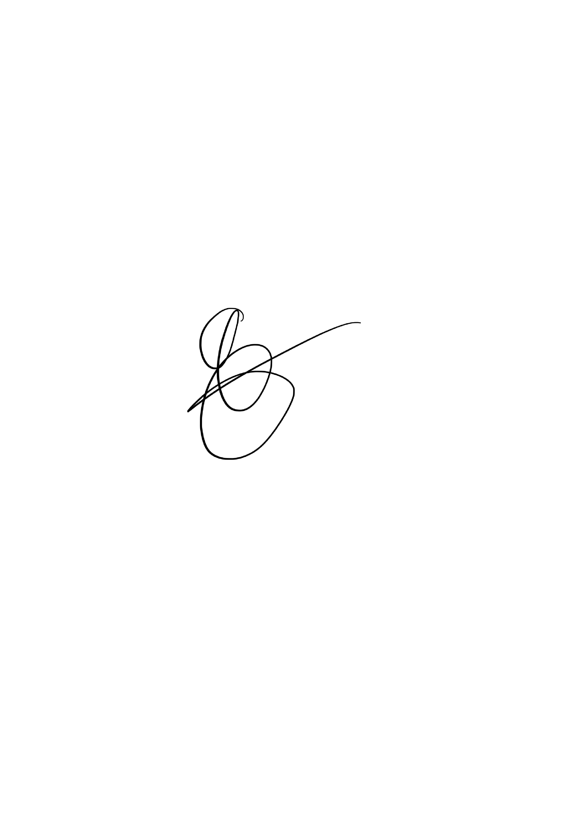
Stop reviewing here
End date & time of the review | 10/10/2026 @ 10:46 AM

Appendix C:
Git log (`finale` branch) | commit d350fc2d8de4984252c76d30c53cb8826536e161  Author: TheAllFather000 <ibrahimsow367@gmail.com>  Date: Sun Sep 20 03:57:13 2026 +0200  final commit; I'm tired bro  commit cf30e9842edb3b3a45533c8efc94ec59436a9d7b  Author: TheAllFather000 <ibrahimsow367@gmail.com>  Date: Sun Sep 20 02:51:11 2026 +0200  intergrated Coloring_cameras, fixed poor load time, made Textured Mesh clickable  commit c8e9630da6cac57b164c347d3847fff915f6df98  Author: TheAllFather000 <ibrahimsow367@gmail.com>  Date: Fri Sep 18 22:33:32 2026 +0200  fixed manual camera row height  commit 29847843d061cbf96aba39d01b4ed5b5d3039aa5  Author: TheAllFather000 <ibrahimsow367@gmail.com>  Date: Fri Sep 18 16:51:39 2026 +0200  fixed camera placement, updated metrics panel  commit cf0e6585911c7ffed84718e4bc9ecd3c908c65dc  Author: TheAllFather000 <ibrahimsow367@gmail.com>  Date: Wed Sep 16 18:30:46 2026 +0200  added camera movement, fixing bugs and slow load time  commit d7bcbc39c391e94babbe647818c5011fc4e1a209  Author: TheAllFather000 <ibrahimsow367@gmail.com>  Date: Wed Sep 9 20:12:19 2026 +0200  merged dockable cameras  commit 95d5d0f92c8d2185dc7814ba3a3c14bc1b372f4e  Author: TheAllFather000 <ibrahimsow367@gmail.com>  Date: Tue Sep 8 21:49:02 2026 +0200  fixed red camera's not being transparent  commit 060e2c5fe6aa0bbf079b678fbcc2d0bab2806537  Author: TheAllFather000 <ibrahimsow367@gmail.com>  Date: Mon Sep 7 19:06:28 2026 +0200  added transparency for non-observing camera's  commit 8058202d3ce16fef6433ef4404fccfd8f659143a  Author: TheAllFather000 <ibrahimsow367@gmail.com>  Date: Mon Aug 31 12:00:10 2026 +0200  added comments  commit 7e9d73bc759e8fd1d9c0a501f2a299b242e03a10  Author: TheAllFather000 <ibrahimsow367@gmail.com>  Date: Sun Aug 30 19:49:31 2026 +0200  finished camera adding  commit 6350b3f25317a0b19438f38105c9cbaaba11d15c  Author: TheAllFather000 <ibrahimsow367@gmail.com>  Date: Sun Aug 30 19:16:24 2026 +0200  added camera placement  commit 7003a44ca1bcf0c9b226832896006400dfc696d2  Author: TheAllFather000 <ibrahimsow367@gmail.com>  Date: Sat Aug 29 19:54:26 2026 +0200  added bar chart func. to MainWindow  commit 4f9c828ace38fe6807b0d2774f7f5f653c69633f  Author: TheAllFather000 <ibrahimsow367@gmail.com>  Date: Fri Aug 28 21:06:10 2026 +0200  finished bar.py for sector bar chart  commit 8ecc11e528b3052b55978b153c74d43079fb7aa9  Author: TheAllFather000 <ibrahimsow367@gmail.com>  Date: Mon Aug 24 22:56:45 2026 +0200  completed metrics panel  commit 21f87ebba2f5afaf5633094fe7e8e62e24736996  Author: TheAllFather000 <ibrahimsow367@gmail.com>  Date: Mon Aug 17 21:37:06 2026 +0200  updated commit  commit f5f9aa4bb071aebf1640096d858a771666411d67  Author: Ibrahim Sow <swxibr002@cs.uct.ac.za>  Date: Fri Aug 14 21:02:52 2026 +0200  Edit camera.py  commit 19c5883a849aee1418ff8ba113b267b8fbf50184  Author: Ibrahim Sow <swxibr002@cs.uct.ac.za>  Date: Fri Aug 14 21:01:30 2026 +0200  Edit sector.py  commit 0eea98f5397d582e649b0cae4689b5479ad322ff  Author: TheAllFather000 <ibrahimsow367@gmail.com>  Date: Fri Aug 14 20:41:48 2026 +0200  completed camera.py, sector.py. may require edits. inform chioma  commit ee57a67fde80670698b367e1f3dd70e052a35b00  Author: Naomi Maanzo <mnznao001@cs.uct.ac.za>  Date: Wed Aug 5 14:00:21 2026 +0200  Upload New File  commit ed7e717541554378032e6e20391ae5cd341131c5  Author: Naomi Maanzo <mnznao001@cs.uct.ac.za>  Date: Wed Aug 5 14:00:04 2026 +0200  Upload New File  commit 65d95f2abb1537608050041677b253f23379d1cb  Author: Naomi Maanzo <mnznao001@cs.uct.ac.za>  Date: Wed Aug 5 13:59:51 2026 +0200  Upload New File  commit 6656e280af589a541b4cfd8e125dfe88327267eb  Author: Naomi Maanzo <mnznao001@cs.uct.ac.za>  Date: Wed Aug 5 13:59:37 2026 +0200  Upload New File  commit f4af8359c42604f4026cbef5646c30d2d47541d9  Author: Naomi Maanzo <mnznao001@cs.uct.ac.za>  Date: Wed Aug 5 13:59:25 2026 +0200  Upload New File  commit 104c4a35ad565a2f7c7a2e0622b2c91a34f84760  Author: Naomi Maanzo <mnznao001@cs.uct.ac.za>  Date: Wed Aug 5 13:59:13 2026 +0200  Upload New File  commit fbb671667cf267ff2bb769531938d8850b8fbaa2  Author: Naomi Maanzo <mnznao001@cs.uct.ac.za>  Date: Wed Aug 5 13:59:02 2026 +0200  Upload New File  commit cab752b835c966d77033a4b13d051699bc5823b8  Author: Naomi Maanzo <mnznao001@cs.uct.ac.za>  Date: Wed Aug 5 13:58:49 2026 +0200  Upload New File  commit 73578de78084a2501a4711774143b5f263fdf1b9  Author: Naomi Maanzo <mnznao001@cs.uct.ac.za>  Date: Wed Aug 5 13:58:36 2026 +0200  Upload New File  commit e2fbe1dc140c39bca22708d87bfab13f84c97377  Author: Naomi Maanzo <mnznao001@cs.uct.ac.za>  Date: Wed Aug 5 13:58:07 2026 +0200  Add new directory  commit fca6acf805e69d1a6141661fed7ce2a8bbddf508  Author: Naomi Maanzo <mnznao001@cs.uct.ac.za>  Date: Wed Aug 5 13:55:52 2026 +0200  Upload New File  commit 34c5cf7d9d5d45f11ad6fcbfdfdec02d56728cb1  Author: Naomi Maanzo <mnznao001@cs.uct.ac.za>  Date: Wed Aug 5 13:55:36 2026 +0200  Upload New File  commit a275a5b22995de9505e128d6ed582bfe93c0bf61  Author: Naomi Maanzo <mnznao001@cs.uct.ac.za>  Date: Wed Aug 5 13:55:19 2026 +0200  Upload New File  commit b086e7e918ca4b8196e55eacce5b15c65ac48f57  Author: Naomi Maanzo <mnznao001@cs.uct.ac.za>  Date: Wed Aug 5 13:55:03 2026 +0200  Upload New File  commit f9edcd45ee09b9321a840cf9619740c266408edc  Author: Naomi Maanzo <mnznao001@cs.uct.ac.za>  Date: Wed Aug 5 13:54:49 2026 +0200  Upload New File  commit 29ffb94ee2a84469d3bc0388301accc2ee7f6f5d  Author: Naomi Maanzo <mnznao001@cs.uct.ac.za>  Date: Wed Aug 5 13:54:34 2026 +0200  Upload New File  commit 8aadcaf6819893ac1eb4fa7cc6e5ba6d5ac92905  Author: Naomi Maanzo <mnznao001@cs.uct.ac.za>  Date: Wed Aug 5 13:54:19 2026 +0200  Upload New File  commit ee42e478ae439530ed12b004443769e7ffbc0032  Author: Naomi Maanzo <mnznao001@cs.uct.ac.za>  Date: Wed Aug 5 13:54:05 2026 +0200  Upload New File  commit e4b913ed37523584a8f321c4a972672c995966d9  Author: Naomi Maanzo <mnznao001@cs.uct.ac.za>  Date: Wed Aug 5 13:51:29 2026 +0200  Upload New File  commit d0bebe0f0a6fe1b75f8187722ec9be257beaf35a  Author: Naomi Maanzo <mnznao001@cs.uct.ac.za>  Date: Wed Aug 5 13:50:02 2026 +0200  Upload New File  commit 123e0f62565cc1c31e12d016da180fd106f1d55c  Author: Naomi Maanzo <mnznao001@cs.uct.ac.za>  Date: Wed Aug 5 13:45:50 2026 +0200  Add new directory  commit 2f8d0c3b9ff9e5848cf2e16ebfab28fb3e89c352  Author: Naomi Maanzo <mnznao001@cs.uct.ac.za>  Date: Wed Aug 5 13:45:35 2026 +0200  Upload New File  commit b005b4f4e3a07e4a114b98b88e3bc6ec4e576363  Author: Naomi Maanzo <mnznao001@cs.uct.ac.za>  Date: Wed Aug 5 13:45:12 2026 +0200  Upload New File  commit aead1fb99e671f206837d1c985aa558a568f11d3  Author: Naomi Maanzo <mnznao001@cs.uct.ac.za>  Date: Wed Aug 5 13:44:49 2026 +0200  Upload New File  commit 94680302332f3ad39e3b33c7dd0b7dba6ef546d2  Author: Naomi Maanzo <mnznao001@cs.uct.ac.za>  Date: Wed Aug 5 13:44:30 2026 +0200  Upload New File  commit c08dec5dc06cfababf3213f7c08aa807a9ef046f  Author: Naomi Maanzo <mnznao001@cs.uct.ac.za>  Date: Wed Aug 5 13:44:08 2026 +0200  Upload New File  commit 015162f9026216eb5791940eeb28bfb9fa498fa3  Author: Naomi Maanzo <mnznao001@cs.uct.ac.za>  Date: Wed Aug 5 13:43:39 2026 +0200  Upload New File  commit c97e955967b5d3d38abe0450b992bf0bd25d548d  Author: Naomi Maanzo <mnznao001@cs.uct.ac.za>  Date: Wed Aug 5 13:42:42 2026 +0200  Add new directory  commit a6651e9d28d7ff65a463e31079992dc37761f7db  Author: Naomi Maanzo <mnznao001@cs.uct.ac.za>  Date: Wed Aug 5 13:42:29 2026 +0200  This is the data folder ,Placeing all data files inside  commit c010a831a9f04b9fe77d33b3e128b2c315242987  Author: Chioma Olebuike <olbchi002@cs.uct.ac.za>  Date: Sun Aug 2 12:13:26 2026 +0200  Initial commit

Appendix D:
